11.4 Volume GP 2 All images captured at 110%

First floor



Second   
floor

First floor

RADIUS

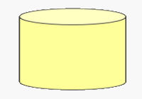

DIAMETER

HEIGHT

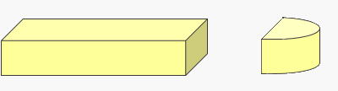

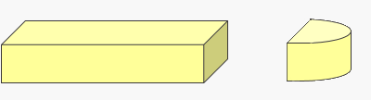

RADIUS

WIDTH

LENGTH

HEIGHT

HEIGHT

24 feet

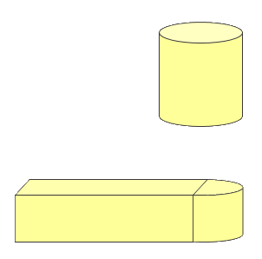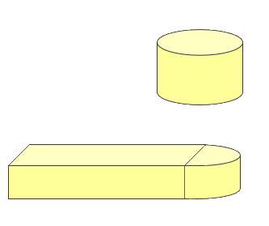

FIRST FLOOR

SECOND FLOOR

12 feet

60 feet

9 feet

24 feet

24 feet

15 feet

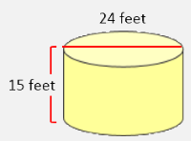

SECOND FLOOR

Snipped from the white background and switched background in paint.net

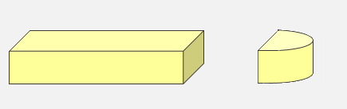

FIRST FLOOR

24feet

9 feet

9 feet

60 feet

12 feet

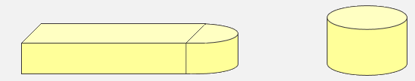

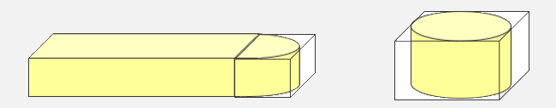

12 feet

60 feet

24 feet

9 feet

24 feet

24 feet

15 feet

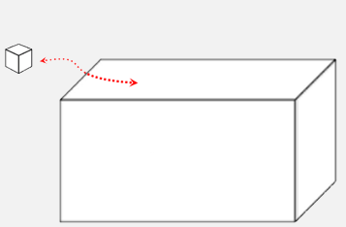

1 BTU cools